# JDE E1 HCM SIG Conference Call:

Please join our monthly conference call to learn more about topics of interest, current issues and workarounds/resolutions, and participate in our Open Forum.

**President** – Justi Montague @ MFA Oil Company

**Vice-President** – Katie Lewis @ Brasfield & Gorrie

**Vendor Liaison/Demo Coordinator** – Jenessa Paproski @ Saskatchewan Indian Gaming Authority

**Bug/Enhancement Coordinator** – Kristine Carver @ Pinal County

**Past President** – Ariel McGee (Ross) @ Colas

# MONTHLY ANNOUCEMENTS

**Quests New Website – Communication Method**

Forum Communication is now how the HCM SIG Board can communicate with the HCM SIG.

Please make sure you change the frequency for Email Notifications to **Daily** as the default is set to weekly!

Go to your profile and Select Email Notifications!

# DEMO

May: Alain DeMorais: Colas ISS: Orchestrations

ENHANCEMENTS

VOTE ON ENHANCEMENTS!

Kristine Carver sent an email via the HCM SIG to request voting on our enhancements on Quest website.

List of 15 enhancements (2014-current) sent to the SIG members - requesting SIG to review and vote with rank 1-5. Hoping to concentrate on these enhancements to submit to Oracle as priority.

If enhancement prior to 2014, please review and update validity of enhancements on Quest website. Email Kristine when complete.

ENHANCEMENT REVIEW SESSION

**We are encouraging HCM Members to present their enhancements during the HCM SIG Monthly calls in order to garner attention, explain further the request, and evaluate the benefit for other customers. Contact Kristine Carver to present!**

Oracle Development in Progress – Keith Sholes

## BUG TRACKING KEY (ESU Not Available Yet)

Status 10 – Description Phase

Status 11 – Code/Hardware Bug (Response/Resolution)

Status 15 - Enhancement Req. Internal (Oracle) Review

Status 16 – Bug Screening/Triage

Status 21 – Cost Required, To Development

Status 25 – Open, Awaiting Code/Hardware review

Status 26 - Open/Failed Verification

Status 30 – More Information Requested. To Filer

Status 69 – PSE to QA: Packages Delivered

Status 80 - Development to QA/Fix Delivered Internal

Status 82 - Q/A to Enhancement Evaluation

Status 87 – Fix verified/Merge Required

Status 91 – Closed, Could Not Reproduce

Status 92 – Closed, Not a Bug

MONTHLY UPDATES

# Open Forum

Nancy @ Logis—Has anyone tested the EEO-4 reporting relative to the new codes?

2017 Note:  JDE has not updated their program yet and thus the new UDC 06/M values 30/31 cannot be used.   (NOTE: JDE BUG Created Apr 25, 2017, EEO-4 / R058514, Bug 25953951 : EONE 9.2 ALTERNATIVE FORM FOR EEO-4 REPORTING, Status 15 Enhancement).

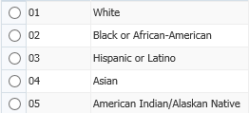  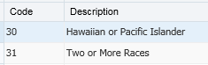

If anyone gets around to testing this and would like to email Nancy, you can contact her at [nhilary@logis.org](mailto:nhilary@logis.org).

Sherri @ OUC

9.2 Enhancement gives error on P055011/W055011D when MC code was $ and Amount or Percent field was blank.

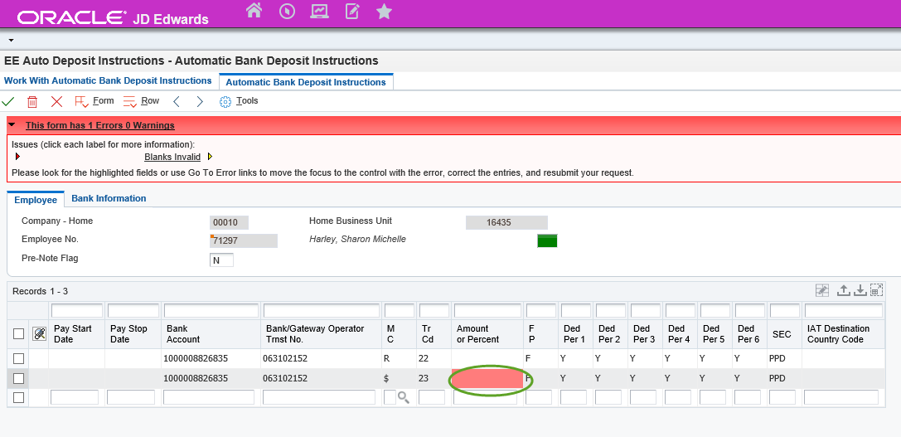

Code current does not apply to P055011/W055011D; but still applies in P055011/W055011A. Bug Number 26779160

Nancy @ Logis

Oracle made the quick fix to change the ESS Manager Review Timecards Grid sort property to Alpha Name (instead of AN8) and is claiming this as a completion to the Enhancement Request from 2015 however this works only for entered timecards.  They did not take on the hard part of fixing the B0501010 Find Missing Timecards Cache so that data still sorts by AN8.   I opened an SR and they said this is a new enhancement request. 29773670

Nancy @ Logis

We took an ESU (JN16925) in December for benefit enrollment and now if you use Plan Option Rates, it doesn’t write the employee deduction correctly during a mid-year change or a retest of eligibility. They stopped writing the rates the DBA instructions, and then tried to fix it, but when you have eligibility rules on a rehire, it was trying to do continuing eligibility rather than new eligibility. Looks correct in P08334, but when you submit, it adds a payroll override deduction which is wrong. This is then written to DBA instructions, and the amount is incorrect.

Nancy @ Logis

Is anyone using the ESS Timecard Mobile Entry app? Katie @ Brasfield&Gorie: We aren’t using it yet, but I am very interested in hearing more. Justi@MFA Oil, we looked in to it, but we don’t use it because it doesn’t record a time in and out for the employee (the fields are in the table). There was also no way to review and approve the time, it wrote directly to the timecard file. (This sounds like it might be for the original time entry app Keith @ Oracle, there is a new one now that uses ESS tables and manager approval).

Keith @ Oracle—Mobile apps strategy at Oracle. We have found that what customers want is a very specific user interface. We design what we think it should be, but we haven’t had the uptake. We are switching gears on how we recommend customers do mobile, we are pointing them more toward using their own UI development tool and then pointing it to JDE using an Orchestration. This allows users to get exactly what they want on the UI. We aren’t going to be developing any additional mobile apps because of that feedback and the adoption.

Kari@ City of Rochester—We have an issue on our 9.2.3 (code current through Feb/March/April-ish) environment where when we change someone’s rate in Basic Compensation, about 5-10% of the time, it doesn’t prompt for a change reason and effective date. It will leave the change reason blank and write the system date as the effective date. There is a report Kari could run that can show every record with a blank change reason code. Also, they should be able to update the records through HR History.

Nancy @ Logis—we are having a problem with rehires not reading the Pay Grade Step rates correctly. Rehire an employee through Quick Hire; if you don’t blank out the hourly rate, it doesn’t re-read the current rate.

Kari@ City of Rochester—When you end an employee in a benefit plan, it doesn’t unenroll dependents.

If you would like items added to our next agenda, please contact jmontague@mfaoil.com.