JDE E1 HCM SIG Conference Call:
Please join our monthly conference call to learn more about topics of interest, current issues and workarounds/resolutions, and participate in our Open Forum.

President – Sherri Harley @ OUC
Vice-President – Ariel Ross @ Colas
Communications Coordinator – Rachel Springob @ City of Ft. Collins
Bug/Enhancement Coordinator – Denise Stewart @ Chocktaw Nation
Vendor Liaison/Demo Coordinator – Kristin Thill-Mckenzie @ Port of Portland

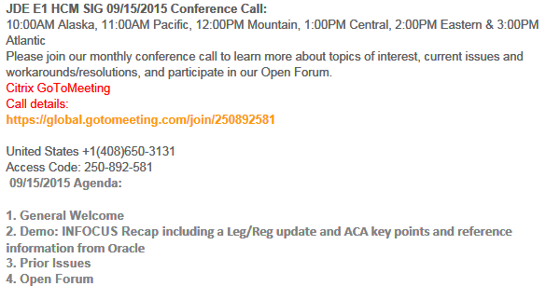
New Call Details Starting in January – Update your Outlook

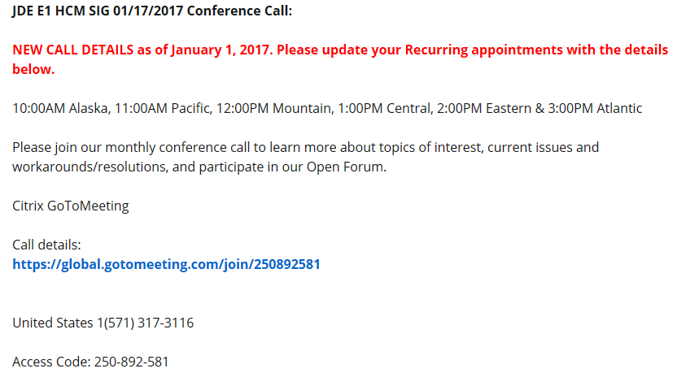

FYI:
Nancy @ Logis – W2 rebuild problem: 10/18/2016
Being released on the year end ESU (Leaving this on until after year end)
  - 9.1 Bug 20656220 Status 87
  - 9.0 Bug 24304894 Status 87
  - 9.2 Bug 24304902 Status 87

ACA Deliverables 9.2
Release 1 Bug 24675810 ESU JN12237
Release 2 Bug 24681279 ESU JN12237
Release 3 Bug 24681316 (due out Jan 17)
ACA Deliverables 9.1
Release 1 Bug 24675805 ESU JM20395
Release 2 Bug 24681267 ESU JM20395
Release 3 Bug 24681309 (due out Jan 17)
ACA Deliverables 9.0
Release 1 Bug 24675792 ESU JL24048
Release 2 Bug 24681259 ESU JL24048
Release 3 Bug 24681302 (due out Jan 17)

If you print W-2s using a report version with an associated BI Publisher template, the BI Publisher template with back-of-the form instructions updated for 2016 was not included in the year-end ESU. Please refer to Support Document 2211403.1 for more information and to download the appropriate template from My Oracle Support

BUG TRACKING(ESU Not Available Yet)
Status 10 – Description Phase
Status 11 – Code/Hardware Bug (Response/Resolution)
Status 15 - Enhancement Req. Internal (Oracle) Review
Status 16 – Bug Screening/Triage
Status 21 – Cost Required, To Development
Status 25 – Open, Awaiting Code/Hardware review
Status 26 - Open/Failed Verification
Status 30 – More Information Requested. To Filer
Status 69 – PSE to QA: Packages Delivered
Status 80 - Development to QA/Fix Delivered Internal
Status 82 - Q/A to Enhancement Evaluation
Status 87 – Fix verified/Merge Required
Status 91 – Closed, Could Not Reproduce
Status 92 – Closed, Not a Bug

Available ESU’s

- Sherri @ OUC: SR 3-12428807422. When in the P07OTO1/W07OTO1C accessed from the payroll workbench, Go to DBA Review > DBA Detail > select a DBA code in the QBE line - click find. The browser just spins and spins, if press F5 it will stop and take me to the end of the data. This is only happening on 9.2 tools 9.2.0.3 Vertex 4.2.
You need to have at least 7 timecards, and at least 30 DBA's with most of them
being benefits or accruals this is also daily time entry. This also happens if not using
the QBE line but you’ve changed a few DBA’s and click SAVE. I have to press F5 to
get the spinning to stop 11/29/2016 Bug 23063717 Status 74 ESU JN12141

- Cindy@ Lehigh Hanson: 9.0 issue VETS4212 -- to fix hiring location name populate instead of the company #. 12/7/2016
  - 9.0 BUG 23262524 ESU JL23910
  - 9.1 Bug 23509173 ESU JM20085
  - 9.2 Bug 23509187 ESU JN12090

- Sarah@EmeraldCube – dreaded EIN validation error. Have followed Alicia’s instructions. Has anyone successfully made EIN or Name changes and produced a correction for 1095C. Make changes in P08119 – not flagging the specific record.
  - Nancy@Logis has! Name correction – but missing an XML element so used new UBE R08130 to force a correction, Nancy – clicked OK so it re-read the name. Access the record and click OK to force it to re-read.
    - if you have access to the database, copy the existing 2 record and change the line number from 0 to 1. Then click OK in the program.
  - Alicia – what program? Look alike or? Sarah – Look alike does not have a place for SSN, so go to offer and coverage and that works but this is not flagging the original as corrected
  - Alicia – on original transmission, what is the status? E accepted with Errors. Covered Individuals form bug prevented it from creating the correction. Alicia can test after call.

Alicia and Sarah tested after the call, and now have 9.1 CORRECTION TO 1095-C NOT SAVED OR NOT POSSIBLE -REPLACEMENT FILE - 2 SUBMISSIONS:
11/15/2016
9.0 Bug 24487754 Status 94 (part of part 2 deliverable Bug 24681259)
9.1 BUG 244681994 - JM20098 Status 74
9.2 Bug 24487740 Status 15 (part of part 2 deliverable 24681279)

- Sherri@OUC: SR 3-12788613681 P085568 Benefit Statement totals are including 'Excluded' plan totals: If the employee is enrolled in multiple $ plans, one of which was excluded. Then the excluded plan is included in the grand totals on the benefit statement. Bug 23734058 - PENDING/FINAL STATEMENTS (P085568) INCLUDES PLAN COSTS FOR EXCLUDED PLANS (additional issues with this based on table related DBA’s – it’s not just if you exclude plans there is an issue with Flex Plans. Nancy commented out the 2 lines that give the grand totals at the top and bottom of the P085568 and the detail is correct it’s just the totals. THIS is probably going to be a long time coming
  - The P085568 Benefit Statement calls N0800365 which states 3 specific conditions of when a plans payroll deduction amount is included in the Pending/final Statements. But those conditions are not taking in to consideration that I have 'Excluded' the plan for a reason. If it's excluded then the totals should also be excluded. This happens when an employee is enrolled in more than 1 plan with flat $ amounts.
I found SAR 7400912 from 2/22/2005 that created this problem.
I think if we exclude the plan in 'Available' plans then it should exclude everything to do with that plan including totals.
Kari@Rochester – can only view/change Def Comp, testing but no issues thus far
Nancy@Logis – having a similar problem
Karen@Smithfield – similar issue and has an SR with Broderick
12/7/2016 9.2 BUG 23734058 Status 74 ESU JN12277

Almost Ready

Still Awaiting on Status Change

New Issues e-Mailed

Patrick White@ Ryan Companies:
The SSA and a large number of states have moved up their deadlines for filing the employer copy of the W-2 forms (the mag/electronic flat files), due to the increase in identity theft and fraudulent refund requests. The SSA deadline has changed from March 31 to January 31 and many states have moved up to January 31 as well for this year. Given our accelerated deadlines, can we find out from Oracle if their standard late Leg/Reg ESU will be “less late” than in prior years, and maybe get an expected release date from them?
Alicia@Oracle: (this was sent out via an email from Quest)JD Edwards EnterpriseOne traditionally delivers the payroll year-end ESU in November followed by a “late Leg/Reg” ESU in January that contains updates due to late-breaking regulatory changes and any other outstanding bugs.
Given the accelerated federal and state filing dates effective this reporting year and so that you can plan accordingly, this notice is to make you aware of the contents of the ESU planned for January 17 availability. Please review these bugs to determine how they may apply to you for year-end processing.
- Pennsylvania Local Lines Not Accumulated by Remit Area (9.0 22888236, 9.1 24943901, 9.2 24943905)
- Electronic Filing for 1099R - Add FATCA Filing Requirement to BIP Template (9.0 24587734, 9.1 24587761, 9.2 24586899)
- Missing W2 BI Publisher Template with 2016 Instructions (9.0 25212013, 9.1 25217530, 9.2 25217546). Current W-2 BIP templates can also be obtained now from My Oracle Support. See Doc ID 2211403.1
- State Tax IDs Greater Than 13 Characters Prints on Two Lines (9.0 24354317, 9.1 24319632, 9.2 24354324)

Open Forum

Nancy@Logis: ACA Eligibility – what is the functionality of the date associated with the record?
Do we need to use new dates, what’s the difference between 2015 eligible record and a 2016 eligible record. You can use the existing 2015 record for eligibility. If a new employee was hired in May and become eligible June 1st is there a date impact with date? Shelly@Oracle: No impact

Alicia@Oracle: HR History a change reason is not written to history for a specific change. If the record is an exact duplicate they do not write a new record in the HR table. It’s based mainly on the change reason. Sarah@Emerald Cube. If everything is the same OK if no record written, if something is different we would expect a change to be written. We would like to use HR history to rebuild a historical record. Sharon@Brasfield: Agrees with Sarah even if the change reason is the same but would like to see the value changes. Rachel@COFC: Fort Collins uses the history records that Sarah just discussed, we use the same process to reconstruct / rebuild the historical record

Alicia@Oracle: Weeks worked report. One coded one in process. Alicia to discuss with Arial@Colas some use cases. Jody@Railworks: Checking to see if she can get more information

Jody@Railworks: Is anyone taking advantage of the deadline extension?
Yes a lot of people are

Nancy@Logis: Anyone tried to add a watermark on their W2’s? They want to put the word Copy on the form. If anyone knows please share with Nancy nhilary@LOGIS.ORG

Sarah@Emerald Cube: Do to several issues they are filing 2015 ACA – if you need to file 2015 data (not talking corrections here) you can file but the form file must be in the 2015 schema and form manifest in 2016 schema

Michael Jepkes@Oracle: we will be adding ability for multiple versions when submitting R08150, so versions can be specific to a year. Yes, we didn't hold R08119B because it does the 1095-C print.

Marcia@Jackson County: 9.1 Today they released JM20431 which replaced JM20395 that we installed this weekend. Nancy@Logis: Bug 25237270. For 9.2 they released 920 = Compare JN12237 and JN12323 (it includes the R08119B – 1095C Print)

Shelly@Oracle: Maintaining a list of bugs so we can look at it and determine if we need to apply
2016 Affordable Care Act (ACA) Reported Issues (Doc ID 2210203.1)
Sharon@Brasfield: Compensation WB – on 9.2 update to the WB as the first level approver the second level approver cannot submit changes because of this. Actually nobody can make a change. There is a bug for this issue. HR Administrator should be able to make any change and currently they cannot. It looks like the functionality was changed by 9.1 Bug 17592719. Bug 17592719 is in 9.2 base code. There are ESUs for both 9.0 and 9.1 with the same Bug fix. I would assume the ESU was never applied to your previous environment. Going forward, this is the way the system will function. Please, let me know if you have further questions
Sarah@Emerald Cube: Is anyone using the R055011 to create pre-notes outside of payroll? Has a customer works fine with Wells Fargo and new company and new bank it is not working correctly. Nancy@Logis does and is not having this issue. DennyRosendo@DigitPro: Is it producing an address book is the file being produce. He had to customize program too. Feel free to email Denny if needed drosendo@digitpro.com
Donna@Blattner Energy: Would like to use self-service – what else is it used for. Please ask any questions to Sharley@ouc.com, RSpringob@fcgov.com, Evelyn.Bian@portofportland.com
Pam@Saris: new requirement for Oregon to have Oregon state id number on the check. The ESU came out for 9.0 and 9.1 came out today 12/20/2016.
24333847 9.1
24810306 N/A 07 9.2
24810295 N/A 07 9.0
Marcia@Jackson County: ACA ESU for upload is scheduled to come out 1/17/17

Leg/Reg Items Under Development Review @ Oracle:

- Jeff @ Semco – SUI – Michigan. Have to file # of employees paid in payroll containing the 12th of the month. Also need subtotals by company on the export file. Nancy had to customize for this and also EEs with multiple tax history types (one record required, was dropping the second). Will determine what pay period includes the 12th and look at timecard history. Will count EE as long as time is not excludable from unemployment insurance. **Logic employed does not cover all use cases (i.e., multiple pay cycle codes). 6/14 –If you would like to provide input, please e-mail Alicia directly Alicia.gambrell@oracle.com. Alicia met with Development, talked about how to code for this. Feedback from development is under review by Alicia.

If you would like items added to our next agenda, please contact sharley@ouc.com!

Contact Sherri or Ariel if you would like to demo or have an idea for a demo

