JDE E1 HCM SIG Conference Call:
Please join our monthly conference call to learn more about topics of interest, current issues and workarounds/resolutions, and participate in our Open Forum.

President – Ariel Ross @ Colas
Vice-President – Justi Montague @ MFA Oil Company
Communications Coordinator – Rachel Springob @ City of Ft. Collins
Bug/Enhancement Coordinator – SuzAnne Garcia @ Pinal County
Vendor Liaison/Demo Coordinator – Kristin Thill-Mckenzie @ Port of Portland

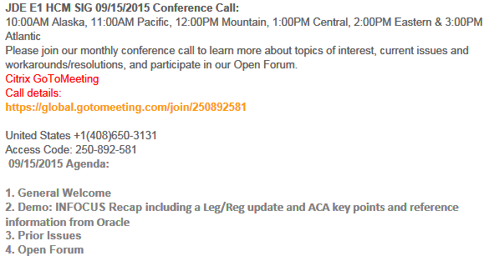

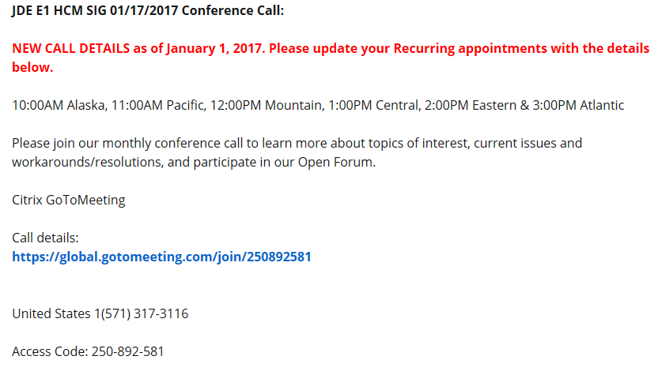

MONTHLY ANNOUCEMENTS

Oracle has released the JDE E1 Late Leg/Reg ESUs, as the 2nd Deliverable. Refer to Oracle Doc ID 743162.1 for complete details. The Oracle document contains information for E1 releases 9.0, 9.1 and 9.2, for US and Canada Payroll processing.

Oracle Support Document 743162.1 (E1:07Y/77Y: 2017 Year End Electronic Software Update (ESU) Information for US (W-2s) and Canadian (T4s)) can be found at: https://support.oracle.com/epmos/faces/DocumentDisplay?id=743162.1

COLLABORATE18
April 22-26 @ Mandalay Bay, Las Vegas

REGISTRATION OPEN –
Jan 31 Hotel Rates Go Up
Early March Early Bird Registration Ends

Accuwage & W2 Processing
Nancy @ Logis:
Does Oracle know Accuwage Online Test is erring for R8907865 relative to the New Changes?
Shelly@Oracle:
The EFTW for the new FF code will be available in the January deliverable.
Nancy@Logis: Confirmed 1/16 that it was in fact included in the Late Reg 2nd Deliverable. 9.2
Justi@MFAOil: Tested and confirmed on 9.1

ACA Deadline Extended!
IRS Notice 2018-06 extends the 2018 deadline from Jan. 31 to March 2 for employers and insurers to furnish individual statements on 2017 health coverage and full-time employee status (Forms 1095-B and 1095-C). The notice also extends prior penalty relief to 2017 incorrect or incomplete reports due in 2018.

Extended deadline for individual statements. Under the Affordable Care Act's shared-responsibility provisions, responsible individuals with minimum essential coverage (MEC) and full-time employees of applicable large employers (ALEs) must receive Forms 1095-B (generally insured coverage) and 1095-C (full-time employees and anyone with ALE-provided self-funded MEC) (GRIST #US 20170106, Nov. 29, 2017; GRIST #US20160115, Oct. 24, 2016). The March 2 extension only applies to furnishing the statements to employees and covered individuals, and IRS will not grant additional extensions. Individuals can file their 2017 federal tax returns before receiving a 1095.

IRS filing deadlines unchanged. Reporters still must meet the Feb. 28 deadline (if filing by paper) or April 2 (if filing electronically) to submit 1095s to IRS, accompanied by the appropriate1094 transmittal form. However, an automatic 30-day extension of the IRS filing deadline is available by submitting Form 8809before the relevant due date.

BUG TRACKING KEY (ESU Not Available Yet)
Status 10 – Description Phase
Status 11 – Code/Hardware Bug (Response/Resolution)
Status 15 - Enhancement Req. Internal (Oracle) Review
Status 16 – Bug Screening/Triage
Status 21 – Cost Required, To Development
Status 25 – Open, Awaiting Code/Hardware review
Status 26 - Open/Failed Verification
Status 30 – More Information Requested. To Filer
Status 69 – PSE to QA: Packages Delivered
Status 80 - Development to QA/Fix Delivered Internal
Status 82 - Q/A to Enhancement Evaluation
Status 87 – Fix verified/Merge Required
Status 91 – Closed, Could Not Reproduce
Status 92 – Closed, Not a Bug

Enhancement Requests

Bug 25876758 Ability to change interim check while it is locked within payroll
Bug 25871132 Reset payments during payroll process per payment
Bug 25891956 Ability to direct an ACH to only go to remainder record
Bug 25876513 Prevent deletion of 1095-C in P08119 once sent to IRS

MONTHLY UPDATES

Available ESU’s

Almost Ready

N/A

Still Awaiting on Status Change

New Items e-Mailed

Nancy@Logis: I have a Tax issue and I’m wondering if anyone else is experiencing this too. Previously when we calculated Interims in 9.20, we would enter pay, calculate (so we had a base expectation), then used FORM > Deselect DBAs for the DBAs we did not want to calculate, then calculated again. We have Pensions assigned through Group Plan DBAs and our Interim Tax Exclusions always calculated these Pension exclusions correctly.

On December 20th, we installed the Vertex Update 20171208 for 4.2.0 (yes, this is old but supported through February) and now our Tax Exclusions are not calculating when we Deselect DBAs. No other JDE code changes have been made nor did I receive any hits on the KG when I searched for this issue.

Is anyone else experiencing this issue? If so, short of manipulating Periods and DBA Periods for the exact DBAs we need to calculate, do you have any workarounds?
Nancy@Logis: Update: We can use 2017 check dates but on the 2018 check dates calculations are incorrect. Work around is entering OTO. SR# 3-16627502791

Nancy@Logis: Is R08150 version, Report Def, and Template still required? It is section 7.4.8 in the Manual however the IRS changed things so I wasn't sure if this is changed too or not.
Sara@Emerald: Was already installed with the ESU – did not have to create the template. 1094-C is not because we are still waiting for the ESU.

Sarah@Emerald: 940 Report – Processing Options have rounding issues. Enter .006 or any decimal amount that is 3 decimals and click OK in processing options. Appears to save but when you access Processing Options again, it has been rounded to .01. This causes the report to calculate wrong. I seem to remember this issue in 9.1 a few years back, but since I don’t have access to my Olathe email…I can’t find the info.
Keith@Oracle: Enter with Oracle
Will be opening SR.

Sarah@Emerald: (941 Report) Medicare excess wage calculation is pulling by quarter, not YTD. When limit is hit, only during that quarter – not showing in other quarter. Again, I seem to remember talking with Nancy Hilary and others about this back in 2014 or so… (on 9.1)
Will be opening SR.
Nancy@Logis - look at BUG 18168071

Sarah@Emerald: Bug 26189372: ON PART II, LINE 16, ALL LNAP MONTHS SHOULD BE IDENTIFIED WITH CODE 2D NOT BLANK. We are having to manually “fix” over 50% of 1095-Cs, to apply 2D on Line 16 for LNAPs. What is anyone else doing? Is this enhancement valuable to anyone else? LNAP is first of the month following 60 days to qualify for benefits. Due to the long period of LNAP need to manually update the remaining periods with 2D after the first month.
Nancy@Logis: Remembers Shelly recommending when setting up your eligibility records – setup LNAP when setting up manually.
Pam@Seris-Regis: Manually adding records you can update.
Sarah@Emerald: Just an FYI: If on Tools 9.1.3 and lower your 1095C will not publish – it will end in error. It is a BIPublisher compatibility issue and Oracle recommends upgrade of Tools or can reach out to Oracle for a POC. Further detail in DOC ID 2238183.1

OPEN FORUM

Sarah@Emeralid: FUTA – Rate in the system is correct but if you apply the rate to the taxable wage, there is a difference from .03 to .13 cents.
Nancy@Logis: Review F07024 maybe for the calculation.

David@Colas: Non-taxable pay code when linked with a taxable benefit – when the employee gets paid – system does not properly exclude for federal. Does work if employee has normal pay code and for state. Issue since going to 9.2 in 2017 and 2018 dates. BUG#27369936 9.2
Sarah: Has negative in excess wages issue with state if difference of work and residence state. Vertex supposed to be fixing in upcoming year.

If you would like items added to our next agenda, please contact aross@colasiss.com.

