JDE E1 HCM SIG Conference Call:
Please join our monthly conference call to learn more about topics of interest, current issues and workarounds/resolutions, and participate in our Open Forum.

President – Ariel Ross @ Colas
Vice-President – Justi Montague @ MFA Oil Company
Communications Coordinator – Rachel Springob @ City of Ft. Collins
Bug/Enhancement Coordinator – SuzAnne Garcia @ Pinal County
Vendor Liaison/Demo Coordinator – Kristin Thill-Mckenzie @ Port of Portland

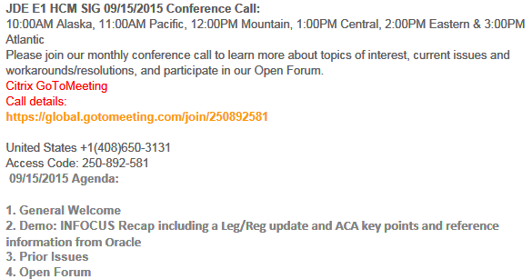

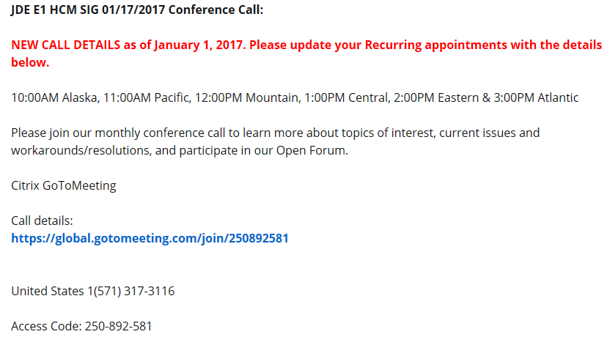

MONTHLY ANNOUCEMENTS

New Board 2017-2018
- President – Ariel Ross
  - Colas ISS aross@colasiss.com
- Vice President –Justi Montague
  - MFA Oil Company jmontague@mfaoil.com
- Communications Coordinator – Rachel Springob
  - City of Ft. Collins rspringob@fcgov.com
- Demo Coordinator – Kristin Thill-Mckenzie
  - Port of Portland Kristin.Mckenzie@portofportland.com
- Enhancement – SuzAnne Garcia
  - Pinal County SuzAnne.Garcia@pinalcountyaz.gov
- Past President Sherri Harley
  - Orlando Utilities Commission sharley@ouc.com

InFocus Call for Presentations! Deadline is May 5
August 14-16, 2017 in Denver, CO

Receive a free registration. Build upon your professional brand. Make important connections!

BUG TRACKING KEY (ESU Not Available Yet)
Status 10 – Description Phase
Status 11 – Code/Hardware Bug (Response/Resolution)
Status 15 - Enhancement Req. Internal (Oracle) Review
Status 16 – Bug Screening/Triage
Status 21 – Cost Required, To Development
Status 25 – Open, Awaiting Code/Hardware review
Status 26 - Open/Failed Verification
Status 30 – More Information Requested. To Filer
Status 69 – PSE to QA: Packages Delivered
Status 80 - Development to QA/Fix Delivered Internal
Status 82 - Q/A to Enhancement Evaluation
Status 87 – Fix verified/Merge Required
Status 91 – Closed, Could Not Reproduce
Status 92 – Closed, Not a Bug

Enhancement Requests

Bug 25876758 Ability to change interim check while it is locked within payroll
Bug 25871132 Reset payments during payroll process per payment
Bug 25891956 Ability to direct an ACH to only go to remainder record
Bug 25876513 Prevent deletion of 1095-C in P08119 once sent to IRS

MONTHLY UPDATES

Available ESU’s

2016 ACA Known Issues Doc ID 2210203.1

Almost Ready

N/A

Still Awaiting on Status Change

Tammy@iamHCM: has anyone experienced where the payroll AAI the default company is not being read and you have to enter every single account
SR being opened with Oracle. Sherri@OUC: Yes it happens here, not sure why it’s happening. Nancy@Oracle: the TimeCard Business Unit must be 000000 and company must be 00000

Denny Rosend@Digitpro: Anyone working on Health & Safety 9.2, bug 23487653 for Case Application – applied ESU but the case/establishment number. When he sets the PO and then you access the application you get an errors for address book number and establishment. Applied ESU but it did not fix the issue.
Call logged with Oracle… Denny sending bad ESU and will keep us updated when a new ESU comes out

New Issues e-Mailed

OPEN FORUM

Leg/Reg Items Under Development Review @ Oracle:

- Jeff @ Semco – SUI – Michigan. Have to file # of employees paid in payroll containing the 12th of the month. Also need subtotals by company on the export file. Nancy had to customize for this and also EEs with multiple tax history types (one record required, was dropping the second). Will determine what pay period includes the 12th and look at timecard history. Will count EE as long as time is not excludable from unemployment insurance. **Logic employed does not cover all use cases (i.e., multiple pay cycle codes). 6/14 –If you would like to provide input, please e-mail Alicia directly Alicia.gambrell@oracle.com. Alicia met with Development, talked about how to code for this. Feedback from development is under review by Alicia.

If you would like items added to our next agenda, please contact aross@colasiss.com.

Contact Ariel or Justi if you would like to demo or have an idea for a demo

