JDE E1 HCM SIG Conference Call:
Please join our monthly conference call to learn more about topics of interest, current issues and workarounds/resolutions, and participate in our Open Forum.

President – Sherri Harley @ OUC
Vice-President – Ariel Ross @ Colas
Communications Coordinator – Rachel Springob @ City of Ft. Collins
Bug/Enhancement Coordinator – Denise Stewart @ Chocktaw Nation
Vendor Liaison/Demo Coordinator – Kristin Thill-Mckenzie @ Port of Portland

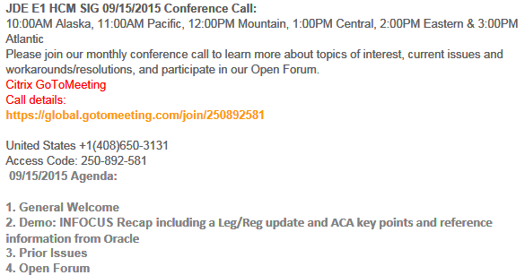
New Call Details Starting in January – Update your Outlook

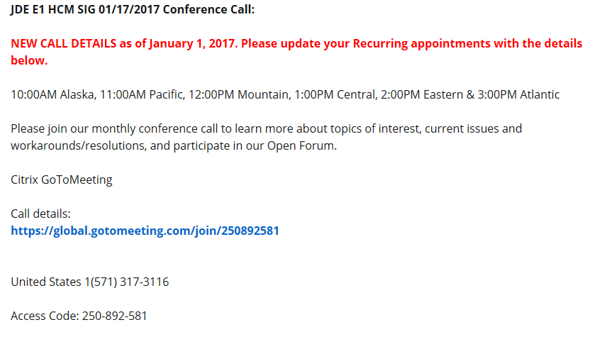

FYI:

2016 ACA Known Issues, 2210203.1
BUG TRACKING(ESU Not Available Yet)
Status 10 – Description Phase
Status 11 – Code/Hardware Bug (Response/Resolution)
Status 15 - Enhancement Req. Internal (Oracle) Review
Status 16 – Bug Screening/Triage
Status 21 – Cost Required, To Development
Status 25 – Open, Awaiting Code/Hardware review
Status 26 - Open/Failed Verification
Status 30 – More Information Requested. To Filer
Status 69 – PSE to QA: Packages Delivered
Status 80 - Development to QA/Fix Delivered Internal
Status 82 - Q/A to Enhancement Evaluation
Status 87 – Fix verified/Merge Required
Status 91 – Closed, Could Not Reproduce
Status 92 – Closed, Not a Bug

Available ESU’s

N/A

Almost Ready

N/A

Still Awaiting on Status Change

New Issues e-Mailed

Open Forum

Nancy@Logis: Benefit totals on P085568 does not have the formatting to show in red or as a negative. Being discussed in project mgmt. Hopefully bug number coming soon. Issue with total flex cost is an ‘Enhancement’ (SR #3-14404198991: 03/02/17 P085568 has incorrect Total Flex Cost amount)

Carmen@iHCM: Vacation balances being rolled into the new year with previous years balances are people handling? Sherri@OUC: manual process after we roll everyone. Nancy@Logis: Uses a custom forfeit computation and the amount lost is displayed on the last check of the year. Has a custom leave accrual table (only looks at timecards through Dec 31st
Tammy@iHCM: What if the work days are in December what do you rollover
Nancy: Anyone used the Anniversary/Fiscal roll… not on call

David @ Core Civic: FYI on NV SUI Issue: 9.0 Took JL24136 for NV SUI and the object to update the PO were not in the ESU. Tried creating a new version and still did not work. Nancy@Logis: It appears the T object did not get updated

Tammy@iamHCM: has anyone experienced where the payroll AAI the default company is not being read and you have to enter every single account
SR being opened with Oracle. Sherri@OUC: Yes it happens here, not sure why it’s happening. Nancy@Oracle: the TimeCard Business Unit must be 000000 and company must be 00000

ACA Items:

Kristin@POP: Sent Original > Rejected > filed replacement > waiting on confirmation > Our replacement was rejected
Sherri@OUC: Sent Original > Rejected > re-filed > Accepted
Cari Phillips@El Paso County: Accepted ****Woo-Hoo*****

  - FYI: Sherri@OUC: OUC does not want us using md5file.com as it’s located in Germany and the DNS is in Russia so we can use one of these
  - https://defuse.ca/checksums.htm
  - https://emn178.github.io/online-tools/md5_checksum.html
Original Note: Mandatory Setup for ACA XML Files for Proper Naming of Files (Doc ID 2131023.1)use https://md5file.com/calculator to calculate check sum and byte size manually

Denny Rosend@Digitpro: Anyone working on Health & Safety 9.2, bug 23487653
for Case Application – applied ESU but the case/establishment number. When he sets the PO and then you access the application you get an errors for address book number and establishment. Applied ESU but it did not fix the issue.
Call logged with Oracle… Denny sending bad ESU and will keep us updated when a new ESU comes out

Has anyone used the SSN checker: Yes but it does not validate what the IRS has. The IRS and SSN are not in sync….. so the checker is not that accurate -ugh

Ross Kimbal@Adams County: How are people handling this!
Nancy@Logis: The safe harbor code Jun vs Jul error, what’s the solution.
Not much of an issue for most. Verify your data either manual or using a SQL statement same as March/April. Then you have to manually update the ESU is coming out on Wednesday. They will be available for tonite or in the morning
Shelly@Oracle: will send out an update to SIG when it’s ready

Pam@Saris Regis: The last name had 3 parts and all 3 were an issue. If the name is more than 20 characters it was an issue, has anyone else had any issue.
Nancy@Logis: before validation or after… Pam has not uploaded her XML yet

Cari Phillips@El Paso County – one person had an error, took one letter off the second last name and it passed

JOIN THE
HCM SIG BOARD!

Open Positions Available
Vice-President
Communications Coordinator
Bug/Enhancement Coordinator
Vendor Liaison/Demo Coordinator

Email Sherri or Ariel if interested or have questions.
Vote will be held at the HCM SIG meeting at Collaborate 2017.

Interested Parties:

- Enhancement Coordinator: Llana McCowan Llana.McCowan@altagas.ca
- Demo Coordinator: Kristin.McKenzie@portofportland.com
IT Manager, Business Systems, Port of Portland
- Communications Coordinator: Rachel Springob RSpringob@fcgov.com
Payroll &Procure to Pay Projects Mgr, City of Fort Collins
- Vice President: Justi Montague jmontague@mfaoil.com, HR Information Systems Manager MFA Oil Company

Leg/Reg Items Under Development Review @ Oracle:

- Jeff @ Semco – SUI – Michigan. Have to file # of employees paid in payroll containing the 12th of the month. Also need subtotals by company on the export file. Nancy had to customize for this and also EEs with multiple tax history types (one record required, was dropping the second). Will determine what pay period includes the 12th and look at timecard history. Will count EE as long as time is not excludable from unemployment insurance. **Logic employed does not cover all use cases (i.e., multiple pay cycle codes). 6/14 –If you would like to provide input, please e-mail Alicia directly Alicia.gambrell@oracle.com. Alicia met with Development, talked about how to code for this. Feedback from development is under review by Alicia.

If you would like items added to our next agenda, please contact sharley@ouc.com!

Contact Sherri or Ariel if you would like to demo or have an idea for a demo

