# JDE E1 HCM SIG Conference Call:

Please join our monthly conference call to learn more about topics of interest, current issues and workarounds/resolutions, and participate in our Open Forum.

**President** – Ariel McGee (Ross) @ Colas

**Vice-President** – Justi Montague @ MFA Oil Company

**Communications Coordinator** – Rachel Springob @ City of Ft. Collins

**Vendor Liaison/Demo Coordinator** – Kristin Thill-Mckenzie @ Port of Portland

**Bug/Enhancement Coordinator** – SuzAnne Garcia @ Pinal County

**Past President** – Sherri Harley @ OUC

# MONTHLY ANNOUCEMENTS

**Quests New Website – Communication Method**

Forum Communication is now how the HCM SIG Board can communicate with the HCM SIG.

Please make sure you change the frequency for Email Notifications to **Daily** as the default is set to weekly!

Go to your profile and Select Email Notifications!

**Collaborate**

#### April 7-11, 2019 San Antonio, Texas

Quest sending out confirmations of session acceptances. Speakers must accept sessions.

Reserve hotel and register for conference.

* February 28, 2019: Presentation Slides due on the template that can be [downloaded here.](https://urldefense.proofpoint.com/v2/url?u=https-3A__s3.amazonaws.com_questoracle-2Dstaging_wordpress_uploads_2018_11_29163259_Speaker-2DPowerPoint-2DTemplate1.pptx&d=DwMGaQ&c=gjvKPeZ-mXe9SkqwIh4YbQmkdowF4nBHjlz_iji7qpY&r=LaREyBDw6o5Wzyq_vP_GidZucg9dwslmx3GvaRaJQjI&m=v0g2LXdh4bBbLrp7xQ9Dzo87fs1ZJFTv8qy6YuSv4HY&s=Q-9qysd8bMSjlg1CWeruln1Y69ZavooUg8AYejJiL-M&e=)

**Join the HCM SIG Board for 2019-2021!**

Looking for volunteers for Vice President*, Communications, Demo and Enhancement Coordinators.

If interested, email Ariel [amcgee@colasiss.com](mailto:amcgee@colasiss.com) or complete [https://www.research.net/r/LeaderInterest](https://urldefense.proofpoint.com/v2/url?u=https-3A__www.research.net_r_LeaderInterest&d=DwMFAg&c=gjvKPeZ-mXe9SkqwIh4YbQmkdowF4nBHjlz_iji7qpY&r=LaREyBDw6o5Wzyq_vP_GidZucg9dwslmx3GvaRaJQjI&m=I84InMk-1vYenSEKub57oBP3I_6PGMsjgjbNQwNJyV8&s=n6wmTMW9KWhCWKnVR265-HMtrlMPKRa5LGxsvy8z2YA&e=).

**ACA Deadlines**

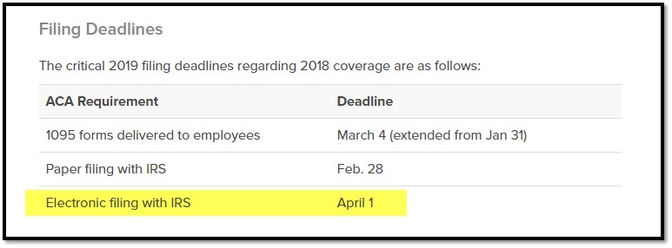

# DEMO

March: iLearn - EOneAcademy

Doug McCarthy, Sales VP [doug@ilearnerp.com](mailto:doug@ilearnerp.com)

Rachel Masters, Training Consultant [rachel@ilearnerp.com](mailto:rachel@ilearnerp.com)

ENHANCEMENTS

VOTE ON ENHANCEMENTS!

SuzAnne Garcia sent an email via the HCM SIG to request voting on our enhancements on Quest website.

List of 15 enhancements (2014-current) sent to the SIG members - requesting SIG to review and vote with rank 1-5. Hoping to concentrate on these enhancements to submit to Oracle as priority.

If enhancement prior to 2014, please review and update validity of enhancements on Quest website. Email SuzAnne when complete.

ENHANCEMENT REVIEW SESSION

**We are encouraging HCM Members to present their enhancements during the HCM SIG Monthly calls in order to garner attention, explain further the request, and evaluate the benefit for other customers. Contact SuzAnne Garcia to present!**

Oracle Development in Progress – Keith Sholes

## BUG TRACKING KEY (ESU Not Available Yet)

Status 10 – Description Phase

Status 11 – Code/Hardware Bug (Response/Resolution)

Status 15 - Enhancement Req. Internal (Oracle) Review

Status 16 – Bug Screening/Triage

Status 21 – Cost Required, To Development

Status 25 – Open, Awaiting Code/Hardware review

Status 26 - Open/Failed Verification

Status 30 – More Information Requested. To Filer

Status 69 – PSE to QA: Packages Delivered

Status 80 - Development to QA/Fix Delivered Internal

Status 82 - Q/A to Enhancement Evaluation

Status 87 – Fix verified/Merge Required

Status 91 – Closed, Could Not Reproduce

Status 92 – Closed, Not a Bug

# MONTHLY UPDATES

# Open Forum

Nancy@Logis: Request for demo! Demo Orchestrator within HR/PR possibly in May?

Colas updating Mailing Name via Orchestrator

Sarah@EmeraldCube: Lock in letter functionality via Orchestrator

Mike@Oracle: Could show a Watchlist- based Notification.

Evelyn@POP: Interim was printed for terminating employee. When processing payroll, code was showing process code 1 instead of showing as already printed. Check number was not in file. Printed payment again to get the code but

R05229 was out of balance which possibly was the cause. Advised by consultant to delete the line and start over – has this happened for others.

Ariel@Colas: We have recommended not printing off the Interim Workbench due to issues in the past with Journal Errors showing for no reason for missing DBA/Taxes causing out of balance. Can redo interim and then no issue. Also need positive pay file submitted during reports on the Payment Workbench. Positive pay file is custom file sent via SFTP during report step.

Rachel@FortCollins: We have minimal checks so we submit Positive Pay via banking website.

Sherri@OUC: 9.2 bug 29331383 ACH Pre-Note Direct Deposit file R055011 and R8907235 is showing SSN instead of AN8

Viola@Balfour: PO#3 on R07235 is what has SSN to show up on R07235 which ccalls R8907235.

Holee@Hamilton: R055011 has event rules hard coded for SSN.

|  |  |  |  |  |  |  |  |  |  |  |  |  |  |  |  |
| --- | --- | --- | --- | --- | --- | --- | --- | --- | --- | --- | --- | --- | --- | --- | --- |
| |  |  |  |  |  | | --- | --- | --- | --- | --- | | Also found … can Oracle document what applications are affected and how so we can review/test.  Mike@Oracle: Data display rule updated via data dictionary. | | | | | |  |  | **E1: 07/07Y: Employee Tax ID SSN is Masked for all HCM Applications (Doc ID 2455166.1)** |  |  | | https://support.oracle.com/epmos/adf/images/t.gif Applies to: JD Edwards EnterpriseOne Human Resources Management - Version 9.0 and later JD Edwards EnterpriseOne US Payroll - Version 9.0 and later JD Edwards EnterpriseOne Canadian Payroll - Version 9.0 and later Symptoms Since applying the latest ESU in HCM it is noted that Employee Tax ID SSN is masked (mask) for all HCM applications and only the last 4 digits are displayed.   What caused this change? Cause This functionality was changed in bugs for SECURING SOCIAL SECURITY NUMBER 9.0 Bug [28422212](https://urldefense.proofpoint.com/v2/url?u=https-3A__support.oracle.com_epmos_faces_BugDisplay-3Fparent-3DDOCUMENT-26sourceId-3D2455166.1-26id-3D28422212&d=DwMFAg&c=gjvKPeZ-mXe9SkqwIh4YbQmkdowF4nBHjlz_iji7qpY&r=LaREyBDw6o5Wzyq_vP_GidZucg9dwslmx3GvaRaJQjI&m=xftnzyC6U1ROALm0tlKbHi_1tkNQwawK-fAaJTqrmDE&s=R2sh4RRCk7FL7mZXrlLaX94NM3Qu9R9_npJ92oSgdW4&e=) 9.1 Bug [28422631](https://urldefense.proofpoint.com/v2/url?u=https-3A__support.oracle.com_epmos_faces_BugDisplay-3Fparent-3DDOCUMENT-26sourceId-3D2455166.1-26id-3D28422631&d=DwMFAg&c=gjvKPeZ-mXe9SkqwIh4YbQmkdowF4nBHjlz_iji7qpY&r=LaREyBDw6o5Wzyq_vP_GidZucg9dwslmx3GvaRaJQjI&m=xftnzyC6U1ROALm0tlKbHi_1tkNQwawK-fAaJTqrmDE&s=Vj_KZItaC-Ifouey7UwxQ9HF-EXwVLFIQks5LVjauFw&e=) 9.2 Bug [28422647](https://urldefense.proofpoint.com/v2/url?u=https-3A__support.oracle.com_epmos_faces_BugDisplay-3Fparent-3DDOCUMENT-26sourceId-3D2455166.1-26id-3D28422647&d=DwMFAg&c=gjvKPeZ-mXe9SkqwIh4YbQmkdowF4nBHjlz_iji7qpY&r=LaREyBDw6o5Wzyq_vP_GidZucg9dwslmx3GvaRaJQjI&m=xftnzyC6U1ROALm0tlKbHi_1tkNQwawK-fAaJTqrmDE&s=ZUVa341ltbxLRshVBdfi0qzsgCvf0sO2c6kykHfKbH8&e=)  This is an Oracle Mandated Security Policy change and changed at the Data Dictionary level. | | | | | |

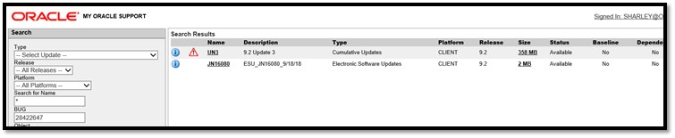

Sherri@OCC: SR submitted for 3-19652473601: P050210 Supplemental Data by Data Type, UDC Description is not pulling into the application

Diana@irexcorp: Anyone else had issues with F0618 not updating after final update? How did you resolve?

Justi@MFAOil: Happened for several months. Issue with CNC backing up the database. SQL out everything and reran payroll.

ViolaBalfour: Security access for users to the F06018 and/or ability to update pay rate into F0618.

If you would like items added to our next agenda, please contact amcgee@colasiss.com.