# JDE E1 HCM SIG Conference Call:

Please join our monthly conference call to learn more about topics of interest, current issues and workarounds/resolutions, and participate in our Open Forum.

**President** – Justi Montague @ MFA Oil Company

**Vice-President** – Katie Lewis @ Brasfield & Gorrie

**Vendor Liaison/Demo Coordinator** – Jenessa Paproski @ Saskatchewan Indian Gaming Authority

**Bug/Enhancement Coordinator** – Jon Richmond @ OUC

**Past President** – Ariel McGee (Ross) @ Colas

# DAILY ANNOUCEMENTS

**Quests New Website – Communication Method**

Forum Communication is now how the HCM SIG Board can communicate with the HCM SIG.

Go to your profile and Select Email Notifications!

# DEMO

AAIS: iSP3/Team Cain

ENHANCEMENTS

VOTE ON ENHANCEMENTS!

List of 15 enhancements (2014-current) sent to the SIG members - requesting SIG to review and vote with rank 1-5. Hoping to concentrate on these enhancements to submit to Oracle as priority.

If enhancement prior to 2014, please review and update validity of enhancements on Quest website. Email Kristine when complete.

ENHANCEMENT REVIEW SESSION

**We are encouraging HCM Members to present their enhancements during the HCM SIG Monthly calls in order to garner attention, explain further the request, and evaluate the benefit for other customers. Contact Kristine Carver to present!**

Oracle Development in Progress – Keith Sholes & Mike Jepkes

Updates to 941

## BUG TRACKING KEY (ESU Not Available Yet)

Status 10 – Description Phase

Status 11 – Code/Hardware Bug (Response/Resolution)

Status 15 - Enhancement Req. Internal (Oracle) Review

Status 16 – Bug Screening/Triage

Status 21 – Cost Required, To Development

Status 25 – Open, Awaiting Code/Hardware review

Status 26 - Open/Failed Verification

Status 30 – More Information Requested. To Filer

Status 69 – PSE to QA: Packages Delivered

Status 80 - Development to QA/Fix Delivered Internal

Status 82 - Q/A to Enhancement Evaluation

Status 87 – Fix verified/Merge Required

Status 91 – Closed, Could Not Reproduce

Status 92 – Closed, Not a Bug

MONTHLY UPDATES

Contact List!

# Open Forum

Sherri @OUC:

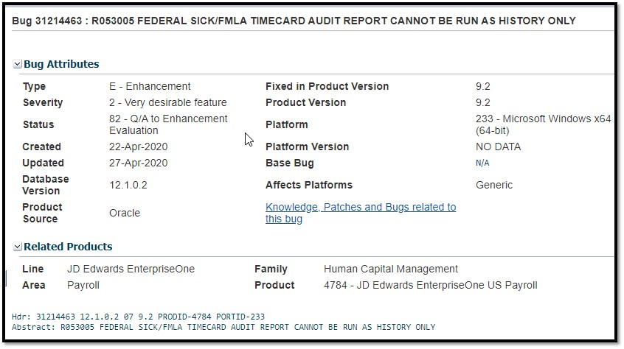

Sherri @OUC:

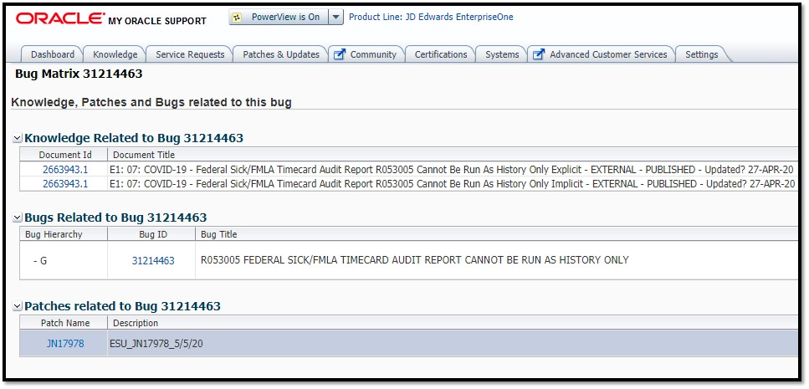

Nancy from Logis

ACH file in Interims you can-not override auto-deposit date. Bug # 31350547

If you would like items added to our next agenda, please contact jmontague@mfaoil.com.