# JDE E1 HCM SIG Conference Call:

Please join our monthly conference call to learn more about topics of interest, current issues and workarounds/resolutions, and participate in our Open Forum.

**President** – Justi Montague @ MFA Oil Company

**Vice-President** – Katie Lewis @ Brasfield & Gorrie

**Vendor Liaison/Demo Coordinator** – Jenessa Paproski @ Saskatchewan Indian Gaming Authority

**Bug/Enhancement Coordinator** – Jon Richmond @ OUC

**Past President** – Ariel McGee (Ross) @ Colas

# DAILY ANNOUCEMENTS

**Quests New Website – Communication Method**

Forum Communication is now how the HCM SIG Board can communicate with the HCM SIG.

Go to your profile and Select Email Notifications!

# DEMO

Patrick Neary & Shaun Meyer; SwiftTest with DWS

ENHANCEMENTS

VOTE ON ENHANCEMENTS!

List of 15 enhancements (2014-current) sent to the SIG members - requesting SIG to review and vote with rank 1-5. Hoping to concentrate on these enhancements to submit to Oracle as priority.

If enhancement prior to 2014, please review and update validity of enhancements on Quest website. Email Kristine when complete.

ENHANCEMENT REVIEW SESSION

**We are encouraging HCM Members to present their enhancements during the HCM SIG Monthly calls in order to garner attention, explain further the request, and evaluate the benefit for other customers. Contact Kristine Carver to present!**

Oracle Development in Progress – Keith Sholes

New W4 Functionality: Mike Jepkes, Oracle

## BUG TRACKING KEY (ESU Not Available Yet)

Status 10 – Description Phase

Status 11 – Code/Hardware Bug (Response/Resolution)

Status 15 - Enhancement Req. Internal (Oracle) Review

Status 16 – Bug Screening/Triage

Status 21 – Cost Required, To Development

Status 25 – Open, Awaiting Code/Hardware review

Status 26 - Open/Failed Verification

Status 30 – More Information Requested. To Filer

Status 69 – PSE to QA: Packages Delivered

Status 80 - Development to QA/Fix Delivered Internal

Status 82 - Q/A to Enhancement Evaluation

Status 87 – Fix verified/Merge Required

Status 91 – Closed, Could Not Reproduce

Status 92 – Closed, Not a Bug

MONTHLY UPDATES

Contact List!

# Open Forum

ACA Extension: Deadline for having forms to employees has been extended to March 4, 2020.

Mike@Oracle: There are a couple of bugs in the system currently to deal with the Tax Methods—we are adding Tax Methods F & G and making a correction to Y. We are also working on making Supplemental Pay work consistently between Tax Methods and Tax Overrides. Mike is going to find and send us the Doc ID (1267994.1)for this, as well as provide us with the Excel sheet he shared.

Carmen@iLearn: Is there a way to combine supplemental pay with regular pay and have it tax correctly, or does it need to be on a separate check? Mike@Oracle: If it’s combined with regular wages, it will tax according to the W4, if it’s not, it will tax supplementally.

Cari@ElPasoCo: I entered a question on the website about Colorado tax calculation. If anyone on the call is from CO, can you please take a look and respond if you know the answer? Since we took the December Vertex update, when our CO tax is being calculated, it’s using the standard deduction of Single for everyone, even if they are married or another filing status. Rachel@FortCollins: There is an Oracle bug for this, they need to create new filing statuses (Colorado, New Mexico, and Oregon). 9.1 30762834; 9.2 30714412. Everyone will have to be treated as single until we get the new filing statuses from Oracle.

Evelyn@PortofPortland: We have been entering a ton of adjustments for year end and are finding that sometimes we don’t think of everything that needs to be adjusted (taxable income, taxes) when entering the adjustment, and we don’t realize we caused in imbalance in Taxable Wages until after we have run Final Update and run our integrity reports. Is there a way to see the impact on taxable wages before we run final update? Nancy@Logis: We export the DBA detail and the stub detail and reconcile it, and then we export the tax detail to make sure it matches. Sherri@OUC: Mike and I worked together on integrity reports for the Federal that run after Final Update; we are waiting to get an ESU from Oracle so it can be tested.

David@ColasISS: Is there an issue Nebraska Mag media file. My user is reporting that Nebraska system states “The RV record position 3-9 does not match the number of RV records submitted.” Justi@MFAOil: We sometimes how to manually edit the files before we upload them. David@ColasISS: We probably need to put in an SR for this file. Katie@Brassfield&Gorie: Did you make sure you don’t have any negatives in the file?

Phillip@PortHouston: Has anyone loaded JN17592 yet for the 2020 W-4 changes it contains. Wondering if anyone encountered any issues. Sherri@OUC: We just installed ours. When we had the first one installed and then applied the fix for the columns not being added in the table. When we went to prod the table conversion the F06017 had to be restored from a backup because it was wiped out. Katie@Brassfield&Gorie: That happened to us in testing as well. Deanna@iLearn: We had that problem with the F06017 in our DV testing. Justi@MFAOil: Back up the F053030 and the F06017 before you run the R89053030 & R8906017 table conversion reports.

Patrick@RyanCompanies: Is there a cross reference guide on Oracle Support between Vertex’s filing status numbers and the JDE filing statuses from 06/MS? Mike@Oracle: We do have one that we use internally, I can send it out.

Tyler@SemcoEnergy: Are there any updates needed for filing the 2019 ACA forms? Mike@Oracle:They changed the year in the XML schema so we need an update to the file. 9.2 30655699 9.1 30655704

Nancy@Logis: at least one of our members ran their ACA and we found where JDE is running one set of numbers for detail and something completely different for summary. We have employees that had the same enrollment for all year and the R08119A is showing a different summary at the top than the detail at the bottom.

W2 Template Issues:

Addresses for employees who are Social Security & Medicare ineligible are not lining up in the box on the envelope.

For the company address line, some of them are shifted down. If anyone can think of why this could occur, please email Nancy@Logis.

The below amounts are incorrect:

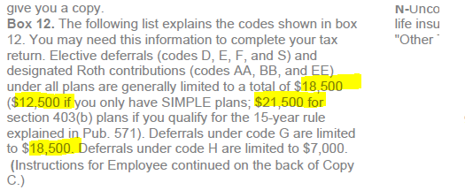

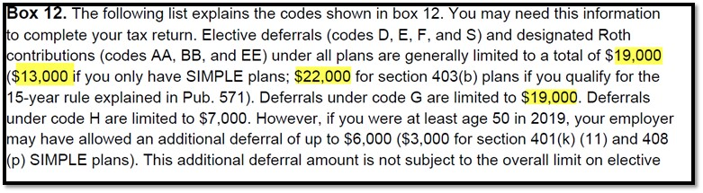

Evelyn@PortofPortland: FYI for Oregon Companies—there is an issue with the line items displayed in box 14. If the employee has more than one line item in box 14 the Oregon Transit Tax does not get displayed. And, JDE is generating multiple W2s if the employee has multiple line items in box 14. Bug 30724749 for 9.2. We got a code change from Oracle we are applying. Nancy@Logis: Can anyone tell us why there is only three items allowed on box 14? It looks like there would be room for four or even five? Mike@Oracle: It was a problem with the internal sequencing. There is a bug that should fix several things.

Shelly: In Special Handling, there is a Tier I Additions & Tier II Additions is this where I would put my Tier I and Tier II Tax? We are a Railroad and need to report this correctly and are using box 14 to use this? Katie@Brassfield&Gorie: it might be valuable to just try it, you can always reset the workbench.

If you would like items added to our next agenda, please contact jmontague@mfaoil.com.