JDE E1 HCM SIG Conference Call:
Please join our monthly conference call to learn more about topics of interest, current issues and workarounds/resolutions, and participate in our Open Forum.

President – Sherri Harley @ OUC
Vice-President – Ariel Ross @ Colas
Communications Coordinator – Rachel Springob @ City of Ft. Collins
Bug/Enhancement Coordinator – Denise Stewart @ Chocktaw Nation
Vendor Liaison/Demo Coordinator – Kristin Thill-Mckenzie @ Port of Portland

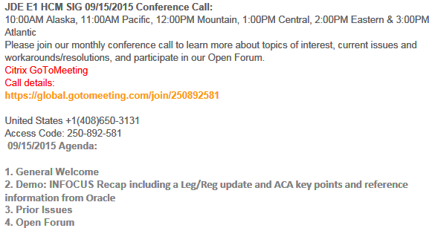

FYI:

JDE IRS tips doc 2149771.1

If the status for all your required test submissions is “Accepted,” did you contact the help desk for confirmation and update of the TCC and/or Form Status? (Telephone Number 1-866-937-4130) Apparently, you need to wait 48 hours after doing this before submitting your live file…

BUGS with POC Status

- Sherri @ OUC: Testing E1 9.2 and Tools 9.2 the self-service flows are picking up a lot of extra space. This does not happen on 9.1 and tools 9.1.4. The space grows when you move the menu bar from top to bottom, side to bottom or side to top etc, it also only happens if you are using Director text SR 3-12581036211 06/21/2016 Bug 23183120 status 69 (I received a POC and it worked) Contact support (open an SR) to get the POC

- Darren@Paul Mueller: We entered a ticket here because of the multiple garnishment issue that Missouri now recognizes. The bug is 06/21/2016 23237610 status 69. This was already fixed in release 9.1, but we are using 9.0 so they are having to recreate the fix in that application release. (was a POC received?)

BUG TRACKING(ESU Not Available Yet)
Status 10 – Description Phase
Status 11 – Code/Hardware Bug (Response/Resolution)
Status 16 – Bug Screening/Triage
Status 21 – Cost Required, To Development
Status 25 – Open, Awaiting Code/Hardware review
Status 26 - Open/Failed Verification
Status 30 – More Information Requested. To Filer
Status 69 – PSE to QA: Packages Delivered
Status 80 - Development to QA/Fix Delivered Internal
Status 82 - Q/A to Enhancement Evaluation
Status 91 – Closed, Could Not Reproduce
Status 92 – Closed, Not a Bug

- Nancy @ Logis – W2 rebuild problem 06/21/2016 Bug 20656220 status 21
- Nancy @ Logis SR 3-11685461771 : 11/10/15 Open Enrollment not calculating DBA using P08505 As of Age. Build Open Enrollment Files correctly calculate the Employee Cost using the employee age as of 01/01/16 as seen from P085520W. During Open Enrollment, the Employee Cost As of Current FAGE is shown. Duplicated 06/21/2016 Bug 22200158 Status 11

- Nancy @ Logis 3-11683375741 : 11/10/15 Employee (Dependent) error on Required Plans during Open Enrollment Employee 2 is a dependent of Employee 1 and has Medical coverage through Employee 1 Family election. Employee 2 correctly receives "You are listed as a dependent of another employee for this category” however the correct Opt Out/Waive functionality is not defaulting and an error is given that an election is required. Employee 2 cannot proceed with Open Enrollment. 06/21/2016 9.1 Bug 22240683 Status 80 / New Bug 23081278 Status 11

- Pat Short Independent Consultant - The biggest ESS issue I have now is: 3-11806940961 R085524 – Not using the correct ending dates when employee switches plans for a Life Qualifying Event. On our Life Qualifying Events the Plan End dates are using the Event Date instead of using the Eligibility Rules and ending the plans the day before new plan start date. So we have lapses in service and or overlapping enrollments. Oracle is working on the fix now. I had to explain to Oracle and the developers that we want it to work as the P08334 (which it should). I opened the call December 2 and they finally started working on the bug at the beginning of February. 06/21/2016 Bug 22387883 Status 11

- Sherri OUC: Org Chart broken as of tools 9.1.5: 9.1 06/21/2016 BUG 23011708 9.2 BUG 23011816 Status 11 Double-click functionality broken in org charts

- Sherri @ OUC: SR 3-12428807422. When in the P07OTO1/W07OTO1C accessed from the payroll workbench, Go to DBA Review > DBA Detail > select a DBA code in the QBE line - click find. The browser just spins and spins, if press F5 it will stop and take me to the end of the data. This is only happening on 9.2 tools 9.2.0.3 Vertex 4.2.
You need to have at least 7 timecards, and at least 30 DBA's with most of them
being benefits or accruals this is also daily time entry. This also happens if not using
the QBE line but you’ve changed a few DBA’s and click SAVE. I have to press F5 to
get the spinning to stop 06/21/2016 Bug 23063717 Status 11

- Pam @ Saris-Regis: An Employee is enrolled in a benefit & has Employee Pay Instructions
(F06106) with a date and rate. Prior to being included in payroll either the
employee goes through Open Enrollment (updated by R085524) or the rates are
recalculated from R083800/R083810. This updates the original Employee Pay
Instructions (F06106) record with the new rate but does not update the
Effective Date (the original date exists in F06106 start date).

  - There is no reason to review the DBA Transaction Detail History (F0719).
It is preferable to stop the original Employee Pay Instructions (F06106) and
start a new Employee Pay Instructions (F06106) with the new effective date
and rate.
Due to requirements of benefit providers, the customer must process Open
Enrollment prior to the first payroll for new hires that are eligible the
month before open enrollment. Because of this, there are no payroll history
records for the DBA instructions with the prior year rate amount. 06/21/2016 Bug 23271512 Status 11

- Cindy@ Lehigh Hanson: 9.0 issue VETS4212 -- to fix hiring location name populate instead of the company #. 06/21/2016 BUG 23262524 Status 11

NEW ISSUES E-Mailed

Sherri@OUC: SR 3-12788613681 P085568 Benefit Statement totals are including 'Excluded' plan totals
The P085568 Benefit Statement calls N0800365 which states 3 specific conditions of when a plans payroll deduction amount is included in the Pending/final Statements. But those conditions are not taking in to consideration that I have 'Excluded' the plan for a reason. If it's excluded then the totals should also be excluded.
I found SAR 7400912 from 2/22/2005 that created this problem.
I think if we exclude the plan in 'Available' plans then it should exclude everything to do with that plan including totals. (No bug yet – but hopeful)
Kari@Rochester – can only view/change Def Comp, testing but no issues thus far
Nancy@Logis – having a similar problem
Karen@Smithfield – similar issue and has an SR with Broderick

Open Forum

Katie@Brasfield & Gorrie: Going through 9.2 upgrade –having a couple of issues. Data entry in a grid it keeps jumping to the top.
Sarah @ Emerald Prism: there is a POC to fix the issue. You need to put in an SR and request a “POC fix” for Bug 22765462 which is broken in 9.2.0.2 and fixed in 9.2.0.4
Sherri@OUC: This is available and you can download the ESU if you are on tools 9.2.0.4 if on 9.2.0.3 then you need the POC

PLATFORM
EnterpriseOne (E1) Application Release: 9.2
EnterpriseOne Tools Release: 9.2.0.2
Enterprise Server/Release: Microsoft Windows (32-bit) 2008 R2
Application Server Version: Oracle WebLogic Server 12c (12.1.3.0.0)
AFFECTED APPLICATION (program name and number)
Web server
ISSUE SUMMARY
Cursor Jumps From Field to Field in 9.2 After Selection. The issues is
causing users to enter the value in the wrong field. For example in sales
order entry screen users end adding the address book number in the "Sold To"
field (because the cursor jumped back to "Sold To" even when they have
clicked in the "Ship To")
STEPS TO REPRODUCE ISSUE (numbered)
1. Log into application P42101 (Manage Existing Order)
2. Click on Add
3. Click the cursor in the "Ship To" field as soon as the Enter New Order
screen comes up and the cursor does not remain in that field
4. The cursor will jump to the default "Sold To" field which is where it
defaults to when you click add and the Enter New Order screen comes up
5. Some examples of application where the issue is happening P42101, P4114.
6. A recording of the issue is uploaded to this bug file CursorJump.WRF

Also seeing in data browser and you are in the F0618/F060116 the export is not exporting all the data the fields are blank Random columns missing

Sherri@OUC: People on IE 8.0 had this issue, they have to use Google Chrome or

Firefox

Chris@Spinnaker: Couple of settings on the newer tools release for import. Limited to 1000 by default. Big imports could cause a huge performance hit, very data intensive. In IE hit F12 and use the developers console – there is a button that says immolator. It changes the way IE works, this is not the compatibility mode.

Sarah @ Emerald Prism: The P08140 processing option #5 -, enter the company number here and update the contact in Who’s who in the company
Shelley@Oracle: The Pre-release will include all the fixes

Shelley @ Oracle: Use an XML validator like AltovaSpy

Nancy @ Logis: SR #3-11685461771: 11/10/15 Open Enrollment not calculating DBA using P08505 As of Age

Once you file it by June 30, you have 60 days to make corrections after that date to get it fixed. But you have to get a successful upload! Not clear about extensions on IRS – what Pam & Sarah found out cannot form extension on FIRE, filled out a form but it’s not clear.
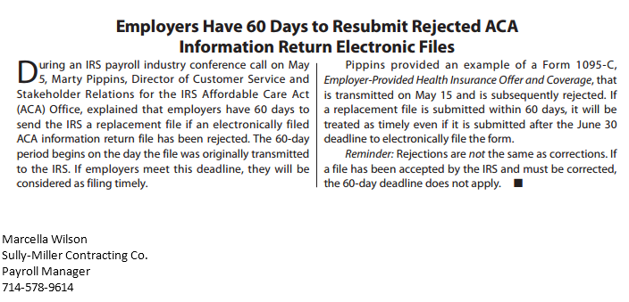

Leg/Reg Items Under Development Review @ Oracle:

- Jeff @ Semco – SUI – Michigan. Have to file # of employees paid in payroll containing the 12th of the month. Also need subtotals by company on the export file. Nancy had to customize for this and also EEs with multiple tax history types (one record required, was dropping the second). Will determine what pay period includes the 12th and look at timecard history. Will count EE as long as time is not excludable from unemployment insurance. **Logic employed does not cover all use cases (i.e., multiple pay cycle codes). 6/14 –If you would like to provide input, please e-mail Alicia directly Alicia.gambrell@oracle.com. Alicia met with Development, talked about how to code for this. Feedback from development is under review by Alicia.

If you would like items added to our next agenda, please contact sharley@ouc.com!

Contact Sherri or Ariel if you would like to demo or have an idea for a demo

