# JDE E1 HCM SIG Conference Call:

Please join our monthly conference call to learn more about topics of interest, current issues and workarounds/resolutions, and participate in our Open Forum.

**President** – Justi Montague @ MFA Oil Company

**Vice-President** – Katie Lewis @ Brasfield & Gorrie

**Vendor Liaison/Demo Coordinator** – Jenessa Paproski @ Saskatchewan Indian Gaming Authority

**Bug/Enhancement Coordinator** – Kristine Carver @ Pinal County

**Past President** – Ariel McGee (Ross) @ Colas

# MONTHLY ANNOUCEMENTS

**Quests New Website – Communication Method**

Forum Communication is now how the HCM SIG Board can communicate with the HCM SIG.

Please make sure you change the frequency for Email Notifications to **Daily** as the default is set to weekly!

Go to your profile and Select Email Notifications!

# DEMO

April: Collaborate Review

1. HCM SIG Meeting—Ariel McGee @ Colas ISS
2. Evolving Employee Self Service Requirements & Creative Solutions—Kristin Thill McKenzie @ Port of Portland
3. Abracadabra! Change Rules in Timecard Automation—Justi Montague @ MFA Oil Company
4. Top 5 Things you can do to Improve your JDEdwards HCM User Experience without Customizations—Keith Sholes @ Oracle
5. Affordable Care Act (ACA) Setup and Reporting in JDEdwards—Mackenzie Friesen @ Oracle
6. Payroll Process—Felicia Bratton @ Emerald Cube
7. HCM Tips & Tricks for Complicated Accruals—Carmen Keller @ iAM HCM
8. Upgrading from JDEdwards 9.1 to 9.2 HCM Style—Jenessa Paproski @Saskatchewan Indian Gaming Authority

ENHANCEMENTS

VOTE ON ENHANCEMENTS!

Kristine Carver sent an email via the HCM SIG to request voting on our enhancements on Quest website.

List of 15 enhancements (2014-current) sent to the SIG members - requesting SIG to review and vote with rank 1-5. Hoping to concentrate on these enhancements to submit to Oracle as priority.

If enhancement prior to 2014, please review and update validity of enhancements on Quest website. Email Kristine when complete.

ENHANCEMENT REVIEW SESSION

**We are encouraging HCM Members to present their enhancements during the HCM SIG Monthly calls in order to garner attention, explain further the request, and evaluate the benefit for other customers. Contact Kristine Carver to present!**

Oracle Development in Progress – Keith Sholes

## BUG TRACKING KEY (ESU Not Available Yet)

Status 10 – Description Phase

Status 11 – Code/Hardware Bug (Response/Resolution)

Status 15 - Enhancement Req. Internal (Oracle) Review

Status 16 – Bug Screening/Triage

Status 21 – Cost Required, To Development

Status 25 – Open, Awaiting Code/Hardware review

Status 26 - Open/Failed Verification

Status 30 – More Information Requested. To Filer

Status 69 – PSE to QA: Packages Delivered

Status 80 - Development to QA/Fix Delivered Internal

Status 82 - Q/A to Enhancement Evaluation

Status 87 – Fix verified/Merge Required

Status 91 – Closed, Could Not Reproduce

Status 92 – Closed, Not a Bug

MONTHLY UPDATES

# Open Forum

Sherri @ OUC--Bug 29643895 (9.2.3)SSN masked on W2s, but is required by the IRS to be on the form. Mike Jepkes said at Collaborate this will be fixed, and they won’t necessarily be waiting until year end to fix this so that reprints can be correct.

Sherri @ OUC—Bug 29548356 (9.2.3) Unenrolling an employee from a plan does not unenroll the dependent from the same plan

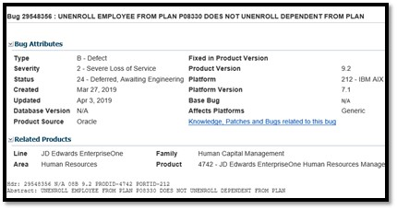

Sherri @ OUC – SR 3-19765931631 I am testing 9.2.3 and if we access Employee Supplemental Data Entry P00092 there is no problem but if we access Employee Information P0801 and then using the Row exit access Supplemental Data Entry P00092 the data is not displayed. They have added in to the code that you have to have Home Business Unit and Company, if you don’t have these fields populated, you will not recall any data. Oracle has listed this as an enhancement. SR 3-19652473601/ Bug 24366276 Missing Description of UDC.

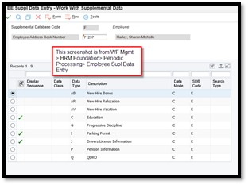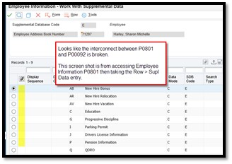

Nancy Hilary @ Logis—who is reviewing the enhancements to determine if they are a bug or an enhancement? Mike @ Oracle—support reviews this process, and they occasionally make mistakes. We only see items that go in to the bug queue for us, although that may be changing. Shelly Clark @ Oracle—sometimes support does have conversations about an enhancement vs a bug, it depends on what the process is and who we are speaking to. Sherri @ OUC—I have had an instance where the support person was told incorrect information by their tech team.

Patrick Faloney @ Brazos Electric—we just implemented ESS last year. We are getting requests from HR to provide benefit statements and W4s. According to the documentation, these use mail merge, which has been a cumbersome process in the past. Are there any changes on the horizon to discontinue using mail merge and go to a BI publisher format? We are working on functional requirements now. Mike@ Oracle—from a Tools perspective, they are in general deprecating Mail Merge as a resource, but we don’t have any specific option for replacing it at this time. I would be interested in hearing customer perspectives on that. Nancy @ Logis –I use View Current Benefits as a form of a statement.

Phillip Howell @ POHA—Recently we implemented 9.2 update 2 in conjunction with a tools release. We have three different vacation policies, one DBA shows earned, and one DBA shows available. We list all three plans in the basis of calc for a third DBA to show the available balance. This makes it more simple for HR/payroll to review balances. We also had our sick accruals set up this way, but as of update 2, this doesn’t work for sick accruals any longer. I have opened an SR with Oracle, and they said the system was working as designed. It seems a little inconsistent that sick and vacation now work differently. Is anyone else having a similar experience? Nancy @ Logis—we are on update 2 and we are not experiencing this issue. Please reach out to [phowell@poha.com](mailto:phowell@poha.com) if you’d like to share.

Sherri @ OUC—We had a corrupt record and our CNC guy was testing reports, his checkmark was gone. This was caused by a corrupt record in the F00950. We just moved the security from the *PUBLIC role to the inquiry role. E1: SEC: Security Does Not Take Effect Due to Corrupt Record in F00950, Column FSTEXTID ( Doc ID 1320072.1 </epmos/faces/DocumentDisplay?parent=SrDetailText&sourceId=3-19628425921&id=1320072.1> )

Phillip @ POHA—I saw a lot of digital transformation sessions @ Collaborate. Job Title on the Organizational screen has to be typed in and does not autopopulate based on the job type and step. We previously had a customization in the P0801ORG that would autopopulate the job title based on job type and step. Does anyone know of Orchestration or UX1 that would do this for you automagically? If we could replicate some data in some places, it would really help. Keith @ Oracle—there is an Orchestration we are working on that will allow you to add functionality to a button, it’s not available yet, but it may be an option to retrieve the description and populate it via a button. Sherri @ OUC—could we create a processing option that would allow the users to choose whether or not to populate the job type description from the Job Master to the P0801ORG. Perhaps it has something to do with the job type housed in the F060116 and job title in the F060120. Keith @ Oracle—if you enter an SR for an enhancement request, we can review the functionality and see what the best option is. Ariel @ Colas –we have an Orchestration with a spreadsheet that allows us to do a mass update in to that field. Sherri—we have a UBE that gets the description from the Job Master and then populates the job title in the field. Mike @ Oracle—we can never answer questions that begin with “why”.

If you would like items added to our next agenda, please contact jmontague@mfaoil.com.