# JDE E1 HCM SIG Conference Call:

Please join our monthly conference call to learn more about topics of interest, current issues and workarounds/resolutions, and participate in our Open Forum.

**President** – Ariel Ross @ Colas

**Vice-President** – Justi Montague @ MFA Oil Company

**Communications Coordinator** – Rachel Springob @ City of Ft. Collins

**Bug/Enhancement Coordinator** – SuzAnne Garcia @ Pinal County

**Vendor Liaison/Demo Coordinator** – Kristin Thill-Mckenzie @ Port of Portland

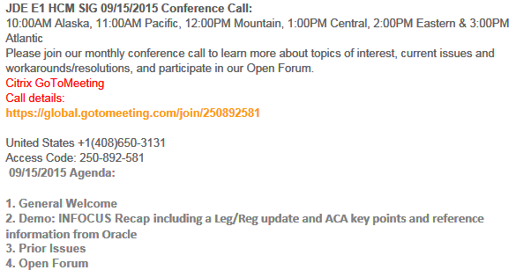

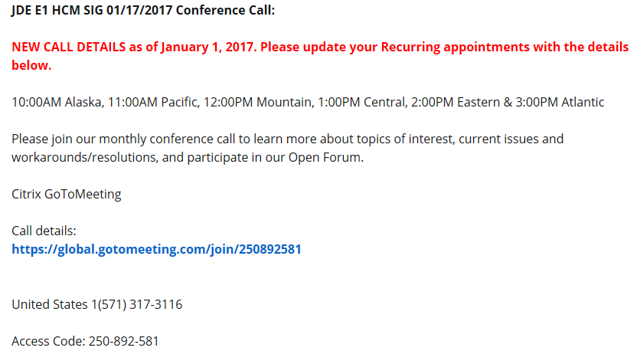

# MONTHLY ANNOUCEMENTS

***COLLABORATE18***

***April 22-26 @ Mandalay Bay, Las Vegas***

***REGISTRATION OPEN –***

***Jan 31 Hotel Rates Go Up***

***March Early Bird Registration Ends***

**February 26, 2018:** Presentation Slides due

**April 6, 2018:** FinalPresentation Slides due

***ACA Deadline Extended!***

IRS [Notice 2018-06](https://www.irs.gov/pub/irs-drop/n-18-06.pdf) extends the 2018 deadline from Jan. 31 to March 2 for employers and insurers to furnish individual statements on 2017 health coverage and full-time employee status (Forms [1095-B](https://www.irs.gov/pub/irs-pdf/f1095b.pdf) and [1095-C](https://www.irs.gov/pub/irs-pdf/f1095c.pdf)). The notice also extends prior penalty relief to 2017 incorrect or incomplete reports due in 2018.

**Extended deadline for individual statements.** Under the Affordable Care Act's shared-responsibility provisions, responsible individuals with minimum essential coverage (MEC) and full-time employees of applicable large employers (ALEs) must receive Forms 1095-B (generally insured coverage) and 1095-C (full-time employees and anyone with ALE-provided self-funded MEC) ([GRIST #US 20170106](https://select.mercer.com/us/ushcr/blurb/350449/), Nov. 29, 2017; [GRIST #US20160115](https://select.mercer.com/article/US20160115), Oct. 24, 2016). The March 2 extension only applies to furnishing the statements to employees and covered individuals, and IRS will not grant additional extensions. Individuals can file their 2017 federal tax returns before receiving a 1095.

**IRS filing deadlines unchanged.** Reporters still must meet the Feb. 28 deadline (if filing by paper) or April 2 (if filing electronically) to submit 1095s to IRS, accompanied by the appropriate1094 transmittal form. However, an automatic 30-day extension of the IRS filing deadline is available by submitting [Form 8809](https://www.irs.gov/pub/irs-pdf/f8809.pdf)before the relevant due date.

## BUG TRACKING KEY (ESU Not Available Yet)

Status 10 – Description Phase

Status 11 – Code/Hardware Bug (Response/Resolution)

Status 15 - Enhancement Req. Internal (Oracle) Review

Status 16 – Bug Screening/Triage

Status 21 – Cost Required, To Development

Status 25 – Open, Awaiting Code/Hardware review

Status 26 - Open/Failed Verification

Status 30 – More Information Requested. To Filer

Status 69 – PSE to QA: Packages Delivered

Status 80 - Development to QA/Fix Delivered Internal

Status 82 - Q/A to Enhancement Evaluation

Status 87 – Fix verified/Merge Required

Status 91 – Closed, Could Not Reproduce

Status 92 – Closed, Not a Bug

## Enhancement Requests

Bug 25876758 Ability to change interim check while it is locked within payroll

Bug 25871132 Reset payments during payroll process per payment

Bug 25891956 Ability to direct an ACH to only go to remainder record

Bug 25876513 Prevent deletion of 1095-C in P08119 once sent to IRS

# MONTHLY UPDATES

Available ESU’s

Almost Ready

**N/A**

## Still Awaiting on Status Change

New Items e-Mailed

**Bug 27145828 Excerpt from Doc ID 2131023.1:**

Note: The checksum created within the Manifest xml from the Manifest XML file generation UBE (R08151) will be in format MD5.  As of 2017 filing the IRS is requiring format SHA-256.   Until associated bugs are complete go to [https://md5file.com/calculator](https://urldefense.proofpoint.com/v2/url?u=https-3A__md5file.com_calculator&d=DwMGaQ&c=gjvKPeZ-mXe9SkqwIh4YbQmkdowF4nBHjlz_iji7qpY&r=LaREyBDw6o5Wzyq_vP_GidZucg9dwslmx3GvaRaJQjI&m=tOD-I7FFCCfHDqVWCUgdCnzpQLlyxnLFttSMzTruZCE&s=RGdQO_2_qEm6apR8D2O0-rng2v_pnbgKs6LoxVMOq-o&e=) and load your Form Data XML document. Before loading your Form Data file to this site, ensure that the value SHA-256 is checked. Drop in or browse for and select your Form Data XML file.

Manually update the ChecksumAugmentationNum element in the manifest xml created by EnterpriseOne with the value returned for SHA-256.

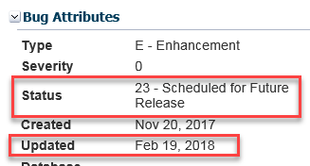

Note if you are on 9.10, the 2nd Deliverable was superseded by JM21600 and contains the corrected XML schema for 2017

Michael@Oracle: ESU will be coming for the SHA-2356 format. Unfortunately delayed – targeted Mid March for release.

Deanna@iHCM: Was successful in test for the workaround.

Nancy@Logis: Detail is correct however Summary is wrong:

This employee has been enrolled in Waive since 12/24/2016.  I’ve seen this in only 2 datasets out of 10 however this is affecting 25% of my employees in this last dataset.  We use Benefit Enrollment as our base for ACA Reporting.

Normally we do not review 1E/2C employees but I starting running SQL Queries against W2 data (since it is easier to be proactive instead of reactive) and found this issue.  In both datasets with the issue, their Waive was not setup as a Default Plan however I’ve changed that field, cleared caching, and rebuilt ACA but it is still writing this ACA data incorrectly.  I’m not finding “Default” stored within their F06106/F08330/F08330B so I’m at a loss why this is reporting wrong.

I reviewed R08119 and it appears that everything is done within B0801400 which was last updated 03/03/17 so I am code current. Possible fix getting code current recently broke this functionality as it’s the recent members being built has the issue.

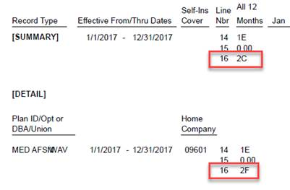

ACA Opt Out – it looks like Oracle has an occasional bug.  Report R08119A Record 1 Detail is showing 2G but Record 2 Summary is showing 2C.  I did not “see” this in analyzing R08119A originally but caught this by doing an analysis between F07832 DD and ACA Forms F08119.  It is not occurring in all datasets though and is visible on the R08119A if you are analyzing every employee carefully (again G to C is not easy to spot).

ACA RD0815017 – Our Burst/Delivery was missing the Override Output File Name 150ACA with the 2017 new schema.

Sarah@EmeraldCube: If employee coverage is terminated mid-month and coverage ends mid-month. February should be 2B for not full time but instead getting blank. Opened SR 3-16821510291 but is manually adjusting for now.

Sarah@EmeraldCube: Anyone else getting blank W2Cs, but XML data is there and valid? W2C required due to changed SS# for employee. R07887 looping on section that does not exist when no change in boxes 1-20 which then produces blank output – affects if change is only in header. Workaround to save BI Publisher and XML, then remove the ‘for each loop.’ Will be opening bug.

Keith@Oracle: Sounds like scenario not considered – enter bug for Oracle update.

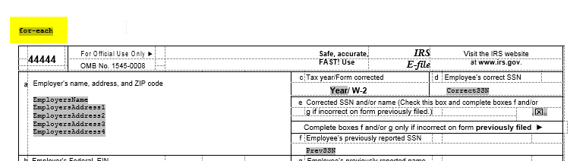

# OPEN FORUM

Sherri@OUC: On self-service when we run personal information build R054101 it creates F054101W. Their emergency contacts were not being displayed or in the workfile build even though they are entered in self-service who’s who data. Will send SQL to find discrepancy. Found bugs: 25816313 – 9.1 and 27033969  - 9.2

Nancy@Logis: Have you verified the line numbers between the Who’s Who data and workfile?

Here’s the SQL to see if you have this issue

|  |
| --- |
| Select distinct (F0111.WWAN8) from F0111, F0101 |
| Where F0111.WWAN8 = F0101.ABAN8 and F0101.ABAT1 = 'E' |
| And F0111.WWTYC = 'E' and F0111.WWAN8 Not In |
| (Select F054111W.ECAN8 from F054111W |
| Where F054111W.ECTYC = 'E'); |

ENHANCEMENTS

SuzAnne@Pinal – Enhancement Coordinator: ***Will be sending out a list of 15 enhancements (2014-current). Requesting SIG to review and vote with rank 1-5. Hoping to concentrate on these enhancements to submit to Oracle as priority.***

If enhancement prior to 2014, please review and update validity of enhancements on Quest website. Email SuzAnne when complete.

If you would like items added to our next agenda, please contact aross@colasiss.com.